Name: _________________________________ Period: _______ Date: _______________

**Linear Inequalities Application Notes**

Inequalities Phrases

* ______________________________________________________________________________
  + a > b
* ______________________________________________________________________________
  + a $≥$ b
* ______________________________________________________________________________
  + a < b
* ______________________________________________________________________________
  + a $≤$ b

Example 1

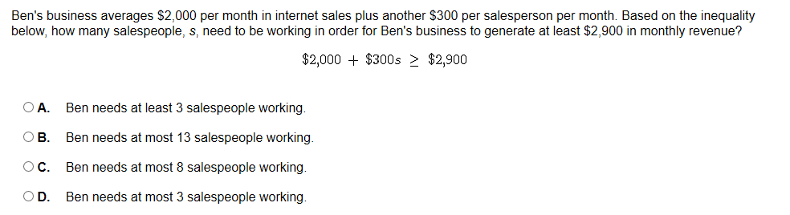

Example 2

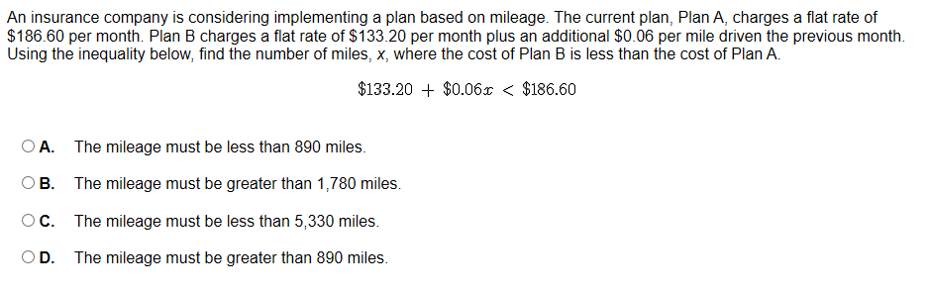

Example 3

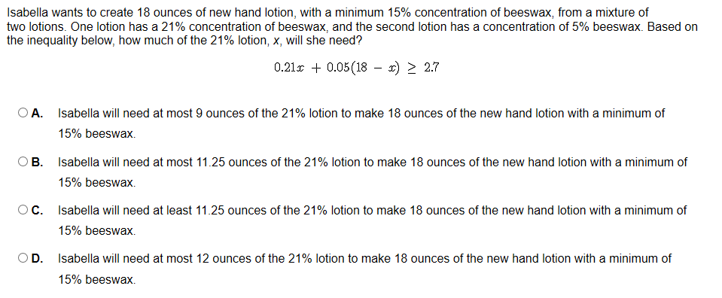

Example 4

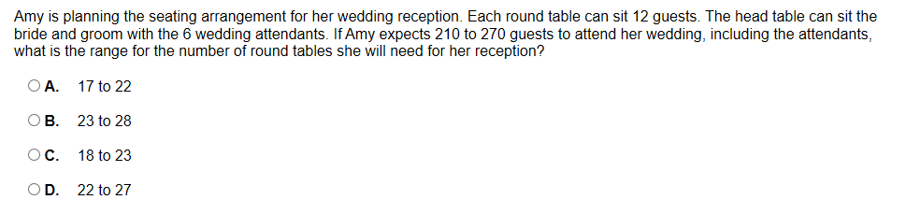

Example 5

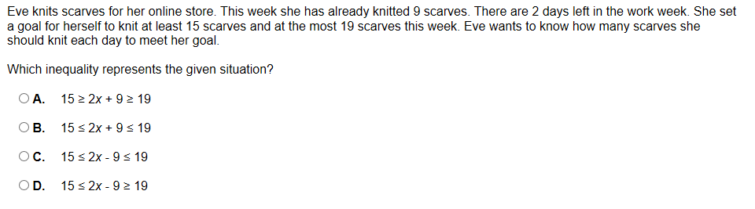

Example 6

